Additional Programs:

1. Develop a LaTeX script to create a document that displays different types of lists such as ordered list, unordered list, and description list.
\documentclass{article}
\begin{document}
\title{Lists in LaTeX}
\date{\today}
\maketitle
\section{Ordered List}
\begin{enumerate}
\item Python
\item Java
\item C++
\end{enumerate}
\section{Unordered List}
\begin{itemize}
\item Apple
\item Mango
\item Orange
\end{itemize}
\section{Description List}
\begin{description}
\item[HTML] Hyper Text Markup Language
\item[CSS] Cascading Style Sheets
\item[SQL] Structured Query Language
\end{description}
\end{document}

OUTPUT:
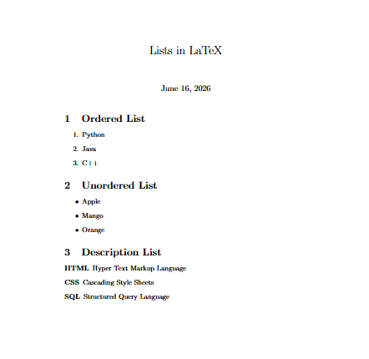

2. Develop a LaTeX script to create a document that demonstrates text formatting styles such as bold, italic, underline, different font sizes, and text alignment.
\documentclass{article}
\usepackage{indentfirst}
\begin{document}
\title{Text Formatting in LaTeX}
\date{\today}
\maketitle
\section{Text Styles}
This is normal text.
\textbf{This text is bold.}
\textit{This text is italic.}
\underline{This text is underlined.}
\section{Font Sizes}
{\tiny Tiny Text}
{\small Small Text}
{\large Large Text}
{\Huge Huge Text}
\section{Text Alignment}
\begin{center}
This text is center aligned.
\end{center}

\begin{flushleft}
This text is left aligned.
\end{flushleft}

\begin{flushright}
This text is right aligned.
\end{flushright}

\end{document}
OUTPUT:
